**SABRE Pilot quick start instructions and cheat-sheet**

**List of changes to “New” SABRE**

* Each reporter is required to create a user account. No longer are you expected to share a single set of log in details.
* There are two types of reporter account.
  + Organisation lead
  + Reporter
* The organisation lead has higher access rights and can control certain aspects of the organisation account
  + Invite users
  + Edit organisation details
  + Edit the list of linked establishments/ hospitals
* Reporters have basic reporting access rights as per “old” SABRE
* The workspace has been updated to give more detail about type of SAE and SAR reported
* The Workspace can be manipulated by displaying a date range
* The Workspace can be exported to a .csv file/ spreadsheet to allow trending and monitoring of reports by clicking the three dots A screenshot of a computer

  Description automatically generated
* Type of report can be selected as the first step 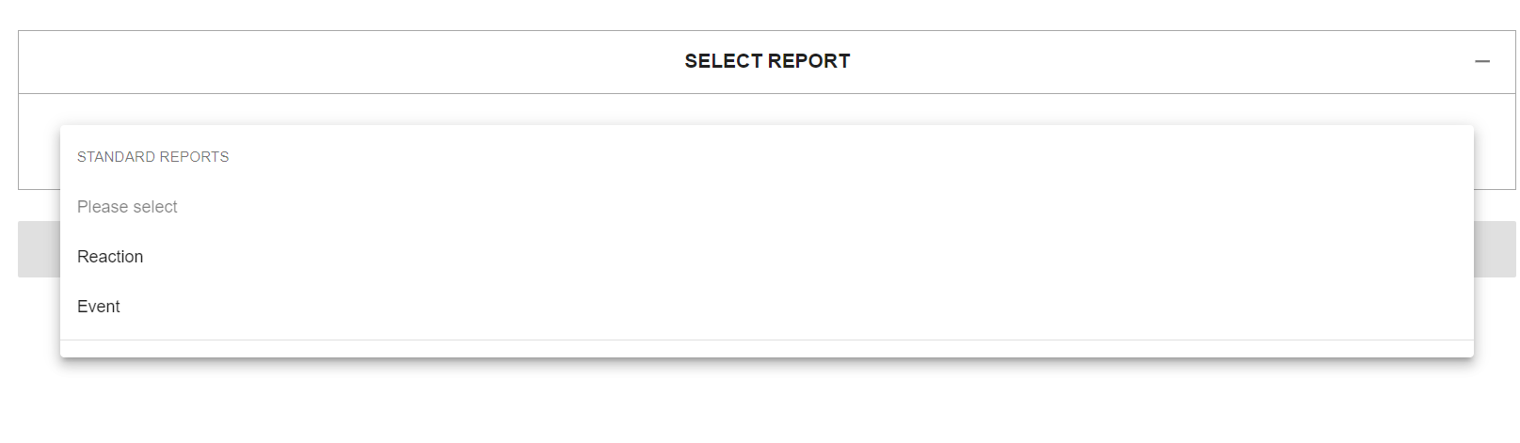
* All fields are mandatory unless marked as optional A screenshot of a medical form

  Description automatically generated
* To help ensure all Notification reports are made “as soon as known” you will no longer be able to report a Notification and Confirmation report concurrently. You are expected to report a Notifcation report seperatly to a Confirmation report.

**Quick start instructions**

**Setting up your Organisation lead account**

1. Hospital to nominate an “Organisation lead” and inform MHRA
2. Receive email with link to new platform
3. Organisation lead to set up their personal account by clicking “create an account”.A screenshot of a login screen

   Description automatically generated
4. Complete the registration form and select your organisation and submit form. A screenshot of a computer

   Description automatically generated
5. Email [sabre@mhra.gov.uk](mailto:sabre@mhra.gov.uk) to state you have created your personal account and await activation of your account
6. Organisation lead then logs into new SABRE A screenshot of a login screen

   Description automatically generated
7. You will see your new Dashboard 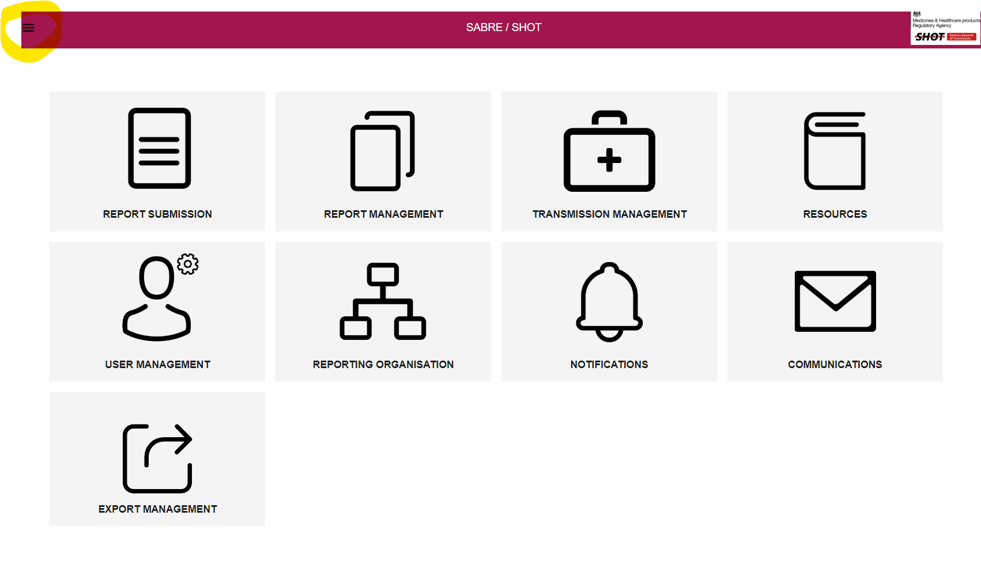
8. Clicking the highlighted menu opens a panel with a list of options as well as links to your profile etc A screenshot of a computer

   Description automatically generated

**Invite reporters to create accounts (Three methods)**

**Method 1**

1. Click the “reporting organisation” tile
2. Click the name of your organisation A white background with black text

   Description automatically generated
3. Click “Invite user” A screen shot of a computer

   Description automatically generated
4. Type the email of the person you wish to invite to be a reporter A screenshot of a phone number

   Description automatically generated
5. Once the reporter receives their invite they should accept it A screenshot of a computer

   Description automatically generated
6. Reporter completes the form and submits it.
7. The reporter can then log in.
8. The organisation lead can repeat the invite process from step 1.

**Method 2**

1. Alternatively, an Organisation lead can complete a new user account on behalf of another reporter from the "User Managemen”" tile A screenshot of a computer

   Description automatically generated

**Method 3**

1. From landing page [Sign in | SABRE/SHOT](https://sabre.mhra.gov.uk/login), reporter clicks “Create account” and completes the form
2. Organisation lead accepts request
3. The Organisation lead, should then accept it, Via Notifications tile, or User Management Tile A group of icons with text

   Description automatically generated or click name in list and accept A screenshot of a computer

   Description automatically generated

**Note 1: An organisation is allowed more than one Organisation lead**

**Note 2: An individual Organisation lead or reporter only needs one user account, however. Should the need arise, a user is permitted to link to different organisation accounts. E.g. You have multiple SABRE accounts for each hospital within your organisation, one individual reporter can be invited to report on both accounts. Should this happen, then the reporter choses which account to access** A screenshot of a computer

**Making a report**

[Sign in | SABRE/SHOT](https://sabre.mhra.gov.uk/login) and log in using your credentials

1. Click report submission and then “New report” 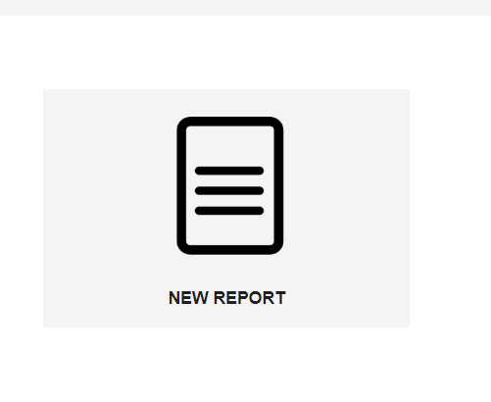
2. Select the report type
3. Complete all mandatory fields and optional fields as appropriate
4. Should you wish to attach a file click “add” A screenshot of a computer

   Description automatically generated
5. Complete the file details and “Cancel” to delete or “Add” to attach A screenshot of a computer

   Description automatically generated
6. Repeat as required.
7. Click “Save draft” or “Submit” to submit your Notification report.
8. To access reports already logged, from the dashboard, click “Report management” tile
9. In the Workspace, hover the mouse over the report you want to open and click or click the hyperlink in the SHOT column to access the SHOT database
10. Click “View report” to openA screenshot of a computer

    Description automatically generated
11. You can now add Footnotes or a Confirmation report to an SAE or Footnotes to an SAR A screenshot of a computer

    Description automatically generated
12. Click the down arrow to access the next section, either Confirmation or Footnotes
13. To open the Confirmation report of an SAE, click the up/down arrow as per snip below, and select “yes” A screenshot of a computer

    Description automatically generated
14. Complete steps 3-7 to complete the Confirmation section and add attachments as required.
15. To add a Footnote, click the “Down arrow” (step 11) next to Footnotes
16. Click “Add Footnote” A screenshot of a computer

    Description automatically generated
17. You can add a freetext comment or files as you wish A screenshot of a computer

    Description automatically generated
18. For each individual Footnote you must click “Add footnote” again to add it and repeat as required.A screenshot of a computer

    Description automatically generated
19. When you have added your Footnotes youe must click “Submit” to submit your Footnotes to MHRA and SHOT. **Note: If you click “Save draft” you will only save them to your report but not submit them**

**Exporting your workspace to a spreadsheet**

1. From the dashboard click “Report management”
2. Click the three dotsA screenshot of a computer

   Description automatically generated
3. Click “Export reports”

1. Select the report type (multiple selections are acceptable) and date range and then Export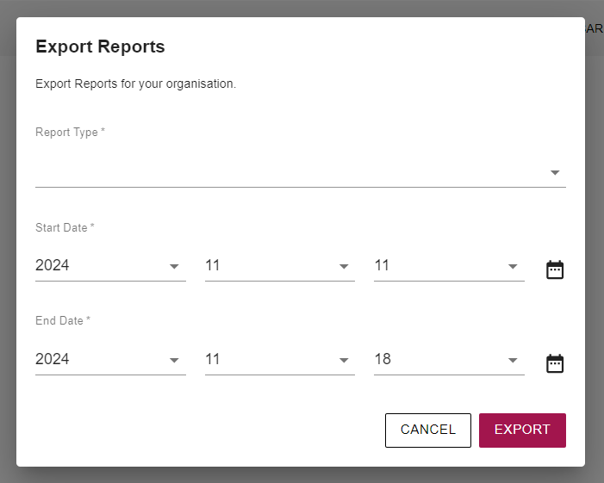
2. Your report is emailed to you, or you can find it in the “Export management” tile to downloadA screenshot of a computer

   Description automatically generated